Computer networks
Packet tracker laboratory exam

Allotted time: 1h 30 min

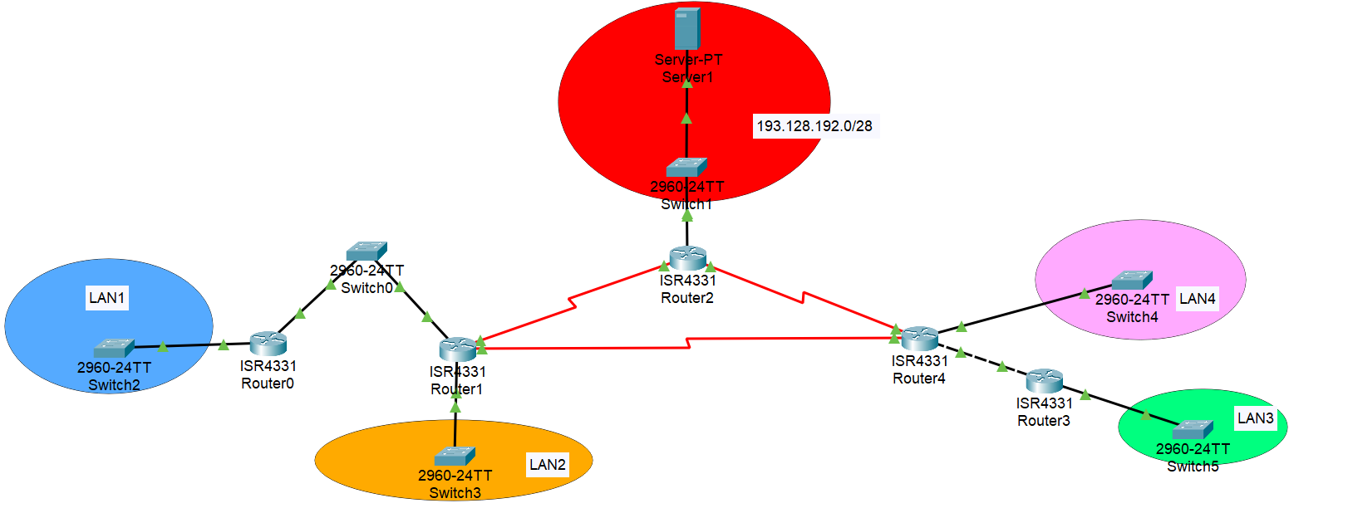

(3p) All the IPs from the local area networks (LAN1, LAN2, LAN3 and LAN4) are allocated from the range 179.26.224.0/23. Perform subnetting (using the minimum subnet size) such that:
- LAN1 can store 120 hosts
- LAN2 can store 98 hosts
- LAN3 can store 50 hosts
- LAN4 can store 30 hosts
For each subnetwork write (in a document or on a piece of paper): the ip address of the network, the network mask, the number of hosts it can store and the broadcast address.
For the networks connecting the routers should come from the address range 10.10.128.0/26.

(2p) Add at least two hosts in each local area network and assign IPs in the following manner: for LAN3 use DHCP and also set the DNS server to the server Server0. For the other local area networks use static IP addressing and set Server0 as the DNS server.

(1p) Setup the server Server 0 to be both a web server and a DNS server. The address of the server should be mapped to the name cs.ubbcluj.ro.

(3p) Configure routing using routing using RIP v2.

Default: 1p

